Project Leader
Australian Energy Market Commission
Level 15, 60 Castlereagh Street
Sydney NSW 2000

Via website: https://www.aemc.gov.au/

10 July 2025

Dear Project Leader

Gas Distribution networks: Connection and permanent abolishment charges [GRC0085]

The Society NSW welcomes the opportunity to provide a short submission a) supporting the Energy Consumer Australia’s proposal for charging customers upfront for a new gas connection and b) establishing a regulatory framework for temporary disconnections and permanent abolishment.

The Society NSW is a member-led organisation that has been serving communities across New South Wales for over 140 years. Our work spans from early intervention to crisis support, helping individuals and families avoid or navigate periods of acute difficulty. While our Members and Volunteers provide essentials like food, clothing, bedding, and assistance with energy bills, we also deliver more than 100 professional services across the state. These programs support people facing complex challenges such as homelessness, domestic and family violence, mental health issues, addiction, and refugee settlement.

The Society NSW supports the Justice and Equity Centre Submission which we understand will be submitted on 14 July 2025 and the proposed changes to national rules concerning the national energy gas framework. The changes will help manage the issue of stranded assets and associated implications for consumers across the energy market and assist with ensuring that no households are disadvantaged. The changes will also help address current deficiencies in the national gas market such as failure to provide adequate consumer guidance, accelerated depreciation and the winding up of gas networks as we move towards electrification.

The Society NSW agrees to the publication of the submission.

If you have any further queries, please contact our National Director Mr Gavin Dufty (gavin.dufty@svdp.org.au or 0439 357 129).

Regards

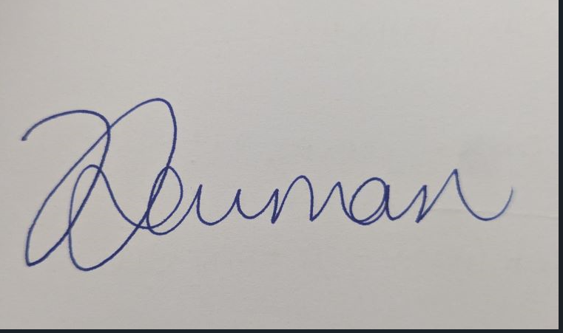

Veronica Newman
Director, Government Relations and Policy

