Mid-West and South-West gas distribution network

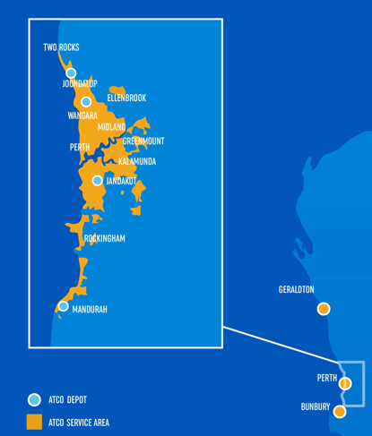

More detailed maps of the ATCO Gas Mid-West and South-West Gas Distribution Systems showing individual sections of the network are available on the ATCO Gas website at the web address below.

<https://www.atco.com/en-au/for-business/natural-gas/wa-gas-network/network.html>